Eaton Guide Specification
Notes and instructions to Specwriter

The following guide specification is offered for your assistance in specifying this product as part of a CSI (Construction Specification Institute) compliant document.
This guide specification has been created in MS Word and uses Word features including Styles and Review to assist in editing and formatting. You may also find it helpful to view the document in Outline mode when editing or selecting sections to copy/paste into your base document.

Styles
Styles are provided for all paragraph types described in the CSI Masterformat. Applying a Style to text will provide the correct indentation, paragraph letter/number, font, capitalization, etc…. Styles are shown on the right-hand side of the Word “Home” ribbon.
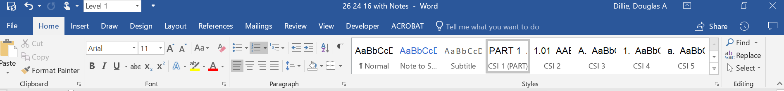
Review
“Notes to Specwriter” (when available) are provided using the Reviews feature in Word. To view “Notes to Specwriter” select “All Markup” in the Tracking dropdown menu on the Review ribbon. To hide notes, select “No Markup”. You can advance from one note to the next using the Previous and Next buttons on the same ribbon. In earlier versions of MSWord hide notes by un-checking ‘Comments’ under Review>SH
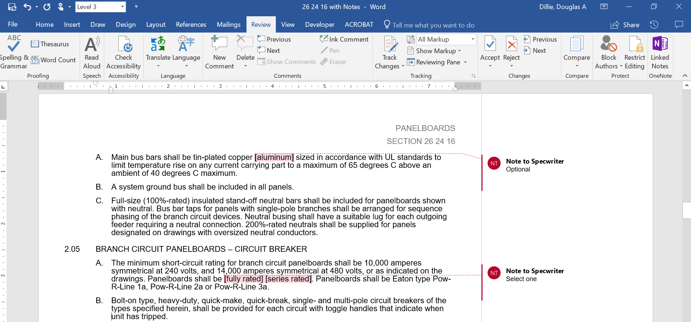
Outline view
The Outline view within Word is often helpful when editing or copying sections from this Guide Specification. Also, when pasting sections from this document into a base document the specwriter may want to consider using right-click and “Merge Formatting’ or ‘Keep Text Only” features.

Section 26 18 29

METAL-ENCLOSED non-segregated phase bus duct – MEDIUM VOLTAGE

General

Scope

The Contractor shall furnish and install the equipment as specified herein and as shown on the contract drawings.

The medium voltage bus distribution system and associated equipment shall have the electrical characteristics and arrangements as shown on the drawings.

Related Sections

Section 26 13 26 – Metal-Clad Switchgear (VacClad-W) – Medium Voltage

Section 26 18 39 – Motor Starters (AMPGARD) – Medium Voltage

References

The bus and components shall be built in accordance with the latest ANSI (C37.23) and other applicable standards.

Submittals – for review/Approval

The following information shall be submitted to the Engineer:

Master drawing index

Riser or isometric drawing

Floor plan

Component list

Conduit entry/exit locations

Assembly ratings including:

Short-circuit rating

Voltage

Continuous current

Basic impulse level

Cable terminal sizes

Busway connection to other equipment

Space heater circuit wiring diagram where applicable

Descriptive bulletins

Product data sheets

Submittals – for construction

The following information shall be submitted for record purposes:

Final as-built drawings and information for items listed in Paragraph 1.04, and shall incorporate all changes made during the manufacturing process.

Certified production test reports

Installation information

Seismic certification and equipment anchorage details as specified

Qualifications

The manufacturer of the assembly shall be the manufacturer of the major components within the assembly.

For the equipment specified herein, the manufacturer shall be ISO 9001 or 9002 certified.

The manufacturer of this equipment shall have produced similar electrical equipment for a minimum period of five (5) years. When requested by the Engineer, an acceptable list of installations with similar equipment shall be provided demonstrating compliance with this requirement.

Provide Seismic tested equipment as follows:

The equipment and major components shall be suitable for and certified by actual seismic testing to meet all applicable seismic requirements of the [latest International Building Code (IBC)] [latest California Building Code (CBC) with OSHPD Amendments]. [The equipment shall have OSHPD Special Seismic Certification (OSP) Pre-Approval.]

The Project Structural Engineer will provide site specific ground motion criteria for use by the manufacturer to establish SDS values required.

The IP rating of the equipment shall be 1.5

The Structural Engineer for the Site will evaluate the SDS values published on the [Manufacturer’s] [OSHPD] website to ascertain that they are "equal to" or "greater than" those required for the Project Site.

The following minimum mounting and installation guidelines shall be met, unless specifically modified by the above referenced standards.

The Contractor shall provide equipment anchorage details, coordinated with the equipment mounting provision, prepared and stamped by a licensed civil engineer in the state. Mounting recommendations shall be provided by the manufacturer based upon the above criteria to verify the seismic design of the equipment.

The equipment manufacturer shall certify that the equipment can withstand, that is, function following the seismic event, including both vertical and lateral required response spectra as specified in above codes.

The equipment manufacturer shall document the requirements necessary for proper seismic mounting of the equipment. Seismic qualification shall be considered achieved when the capability of the equipment, meets or exceeds the specified response spectra.

Regulatory Requirements

Delivery, STORAGE AND HANDLING

Equipment shall be handled and stored in accordance with manufacturer’s instructions. One (1) copy of these instructions shall be included with the equipment at time of shipment.

operation and Maintenance Manuals

Equipment operation and maintenance manuals shall be provided with each assembly shipped, and shall include instruction leaflets and instruction bulletins for the complete assembly and each major component.

Field Measurements

The Contractor shall be responsible for making all field measurements necessary to fabricate, install and connect the bus system.

Products

Manufacturers

Eaton

__________

__________

The listing of specific manufacturers above does not imply acceptance of their products that do not meet the specified ratings, features and functions. Manufacturers listed above are not relieved from meeting these specifications in their entirety. Products in compliance with the specification and manufactured by others not named will be considered only if pre-approved by the engineer ten (10) days prior to bid date.

ratings

Voltage: ____, ____ phase, ____-wire, with ground bus.

Current rating: ____ or as shown on drawings.

Short-circuit rating: ____ rms symmetrical.

Basic impulse level: _____ kV.

bus

The conductors shall be 98% conductivity bar-type copper with silver-plated joints. These bars shall be mounted on supports of track-resistant, flame-retardant xenoy polymer, glass polyester, or epoxy, and shall be insulated their entire length by fluidized epoxy coating for 2400-volt service and above. Typical bus joints shall use double splice plates and be insulated with removable boots. For non-standard joints, heat shrink tubing or tape may be used to insulate the joint. The conductors shall be capable of carrying its rated current continuously without exceeding a temperature rise of 65 degrees C based on a 40 degree C ambient. Conductors shall be braced to withstand the available fault currents as indicated on the contract drawings.

A 0.25 x 2.0-inch bare copper ground bus shall be supplied and bolted to each enclosure to provide continuous electrical ground when adjacent enclosures are connected together, to minimize the possibility of circulating currents.

wiring/terminations

Provide an external 2-hole ground pad at each end for ground connections or connect the ground bus in the enclosure to the ground bus in the terminal equipment as applicable.

miscellaneous devices

Provide wall flanges, vapor barriers, expansion joints, and equipment terminations where indicated on drawings.

Enclosures

The enclosures shall be #11 aluminum or equivalent steel or stainless steel, as applicable. Enclosures shall be dustproof with bolted removable covers.

Nameplates

finish

The finish shall consist of one (1) coat of gray (ANSI 61) thermosetting, polyester powder paint applied electrostatically to pre-cleaned and phosphatized steel. The coating shall have corrosion resistance of 600 hours to 5% salt spray. Prior to shipment, the complete assemblies, indoor as well as outdoor, shall be given 1.5 to 2.0 mil thick exterior finish spray coat of air drying high-gloss gray enamel.

accessories

[The entire bus run] [The outdoor portion of the bus run] shall be provided with space heaters in accordance with the manufacturer’s recommendations. The [500 volts] [250 volts] rated heaters shall be applied at [240 volts] [120 volts] for longer life. The heaters shall be [continuously energized] [thermostatically controlled]. [The heaters shall be wired for connections to terminal blocks in the terminal equipment] [Provide junction box with terminal strip for purchaser’s ac connections] Bus duct submittal drawings shall indicate total heater circuit wattage to enable Contractor to properly size feeders.

The indoor enclosures shall be designed to be [suspended by hangers] [supported from below by structural supports]. Outdoor bus runs shall be designed to be supported from below by structural steel. The hanger rods and steel supports shall be supplied and installed by the Contractor. The manufacturer shall provide mounting provisions and supply all necessary information to the Contractor for the design of these supporting devices.

Execution

Factory Testing

The following standard factory tests shall be performed on the equipment provided under this section. All tests shall be in accordance with the latest version of ANSI and NEMA standards.

Normal frequency dielectric

Space heater electrical operation and control wiring check

The manufacturer shall provide three (3) certified copies of factory test reports.

Field Quality Control

MANUFACTURER’S Certification

Training

The Contractor shall provide a training session for up to five (5) owner’s representatives for ______ normal workdays at a job site location determined by the owner.

The training session shall be conducted by a manufacturer’s qualified representative.

Installation

The Contractor shall install all equipment per the manufacturer’s recommendations and the contract drawings.

field adjustments

Field Testing

